All Inventors must sign the disclosure before it is submitted.
1. TITLE OF INVENTION: Explainable Deep Learning Approach for Sleep Disorder Detection and Personalized Lifestyle Recommendations

2. PLEASE ATTACH A DESCRIPTION OF THE INVENTION (refer to instructions)
Abstract
Sleep disorders such as insomnia, sleep apnea, and restless leg syndrome are rising globally, yet remain largely underdiagnosed due to limited clinical access, high diagnostic costs, and social stigma particularly in emerging markets like India. This system presents an AI-powered Sleep Disorder Management Platform designed for both clinicians and patients. Clinicians receive interpretable visual reports and uncertainty-aware decision support, reducing black-box limitations. Patients access personalized insights, lifestyle recommendations, and simplified explanations of complex sleep data. By enabling early detection, remote monitoring, and scalable deployment across clinical and wearable ecosystems, the platform addresses a rapidly expanding digital health market while improving public sleep health outcomes.
Technical Description
The invention discloses an artificial intelligence based Sleep Disorder Management System designed to perform automated sleep staging, multi-disorder detection, interpretability generation, uncertainty estimation, and personalized recommendation delivery within a deployable healthcare platform. A prototype modular pipeline is shown in Fig. 1, reflecting the various stages of the system and its minor modules. The system acquires physiological sleep data from single-channel electroencephalography (EEG) devices, full polysomnography (PSG) systems, or compatible monitoring equipment. Single-channel EEG is utilized as the primary input for sleep staging to support portable and edge-device deployment, while additional physiological channels including electromyography (EMG), electrocardiography (ECG), respiratory signals, and oxygen saturation may be incorporated for disorder detection requiring multi-channel analysis.
Collected physiological signals undergo preprocessing including filtering, normalization, and segmentation into standardized sleep epochs. Each epoch is processed through a multi-scale feature extraction module using an Adaptive Atrous Pyramid architecture consisting of parallel one-dimensional convolution branches operating at multiple dilation rates. The outputs of these branches are combined through an adaptive gating mechanism that assigns importance weights to different dilation features. A channel-wise squeeze-and-excitation attention module refines the extracted features, producing compact embeddings representing frequency-dependent EEG characteristics.
Epoch-level embeddings are processed using a lightweight Transformer-based temporal modeling module incorporating sinusoidal positional encoding and multi-head self-attention layers. This module captures inter-epoch temporal dependencies and sleep transition patterns, generating automated classification of sleep stages including Wake, N1, N2, N3, and REM sleep. The architecture is optimized to maintain low computational complexity, enabling real-time execution on portable and edge-compatible devices.
Sleep staging outputs are further analyzed to derive clinically interpretable features such as sleep stage distribution ratios, transition statistics, sleep fragmentation indicators, and REM latency measurements. These derived clinical metrics are combined with physiological features from optional multi-channel signals and processed through a multi-label disorder classification module capable of identifying disorders including insomnia, sleep apnea, periodic limb movement disorder, and bruxism. The system integrates interpretability layers that generate attention-based visualizations, epoch influence mapping, clinician-oriented analytical reports, and simplified patient explanations.
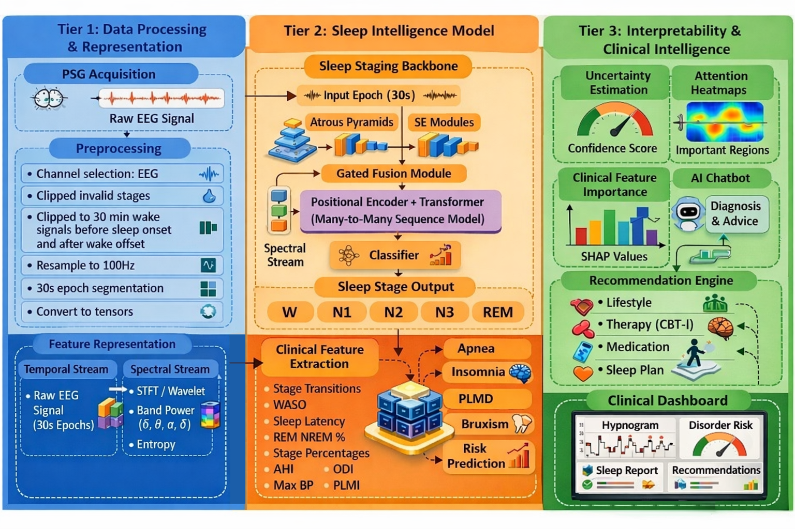
Fig. 1: Data flow of our proposed system modularized into three tiers. The data uploaded by the patient will undergo processing for noise removal and better representation(on the left), further the transformed data is fed to the sleep staging backbone to sequence the sleep stages (top middle) and clinically used features are extracted from the sequence and fed to various ML classifier (bottom middle), Finally the predictions from the models are collected and various interpretable results will be represented as clinically meaningful results and provides assistive features to layman patients (on the right).
Prediction confidence is evaluated using entropy-based uncertainty estimation applied to both sleep staging and disorder classification outputs. Low-confidence predictions generate clinician review alerts to support hybrid human-AI decision workflows. Detected disorders are translated into risk-stratified assessments and processed through a hybrid recommendation engine that integrates AI predictions with structured clinical knowledge to generate personalized behavioural guidance, monitoring strategies, and educational insights.
The system supports deployment across hospital PSG environments, remote monitoring platforms, and portable consumer devices through modular and cloud-compatible architecture.
Advantages and improvements over existing methods, devices or materials
The proposed invention improves accessibility and scalability of sleep disorder diagnostics by enabling reliable sleep staging using single-channel EEG signals while maintaining compatibility with full polysomnography systems when additional physiological channels are required. The Adaptive Atrous Pyramid feature extraction architecture captures multi-frequency temporal characteristics directly from raw EEG signals, reducing dependence on manual signal transformation techniques and improving feature diversity. The lightweight Transformer-based temporal modeling module maintains contextual sleep transition analysis while remaining computationally efficient, enabling deployment on portable and edge-compatible devices, which is typically not feasible with conventional deep learning sleep analysis models.
The invention further enhances diagnostic transparency by integrating explicit clinically interpretable sleep metrics derived from staging outputs into disorder detection. Multi-level explainable artificial intelligence components, including attention-based visualizations, epoch influence analysis, and structured clinician reports, address the black-box limitations commonly associated with AI-driven medical systems. Additionally, entropy-based uncertainty estimation allows the system to identify low-confidence predictions and trigger clinician review, improving diagnostic reliability and supporting hybrid decision-making workflows.
Unlike existing systems that primarily focus on detection, the invention integrates automated disorder identification with risk stratification and personalized management recommendations. The modular architecture allows adaptation to disorder-specific physiological signals, enabling detection of conditions requiring specialized channels while preserving core portability. This unified approach supports continuous monitoring, patient engagement, and long-term disorder management beyond traditional single-time diagnostic frameworks.

Table 1. Comparison among proposed and State-Of-The-Art models
Features/Product | Sleep Staging | Multi Disorder Detection | Input | Personalized Result | XAI | Uncertainty Measure
Proposed | 5 Stages | 9 Disorders | PSG | Lifestyle, remedy, self help | Heatmaps, scoring, importance map explanations | Entropy based alerts
Garmin index sleep monitor | Limited (light, deep, rem) 69.7% | No | Wearable | Personalized to user, sleep coach. | Sleep score and insights
Whoop | Limited (light, deep, rem) | No | Wearable | Sleep planner, quality and recovery score
Oura ring | Limited (light, deep, rem) 79% | No | Wearable | Actionable recordings, habit impact, Oura advisor | Extracts clinical features | Limited, does not provide findings when unsure.
Withings scanwatch | Limited (light, deep, rem) | Provides FDA cleared diagnosis for OSA and AFib | Wearable | Personal baselines trend analysis, Vitality indicator, Predictive AI insights | Localized event detection, report generation | Identifies poor signal regions, inconclusive status.

Potential Commercial Application:
- Clinical decision-support software for sleep laboratories and hospitals to automate sleep staging, disorder screening, and report generation.
- Portable home-based sleep assessment platform integrated with single-channel EEG devices for self-monitoring and early disorder detection.
- Remote patient monitoring solution for telemedicine services, caregiver networks, and chronic sleep disorder management programs.
- Digital health and corporate wellness platform providing personalized sleep analytics, fatigue risk monitoring, and lifestyle recommendation services.
3. INVENTOR(S): (please indicate primary contact with an *) Note: the order that inventors are listed on this form will reflect the order that inventors will be listed on potential patent applications.
NAME DESIGNATION CAMPUS DEPARTMENT CONTACT INFO
Girish S 4th year BTech student Amritapuri CSE(AI) +91 8939027931
R S Harish Kumar 4th year BTech student Amritapuri CSE(AI) +91 9995545138
Anuvind MP 4th year BTech student Amritapuri CSE(AI) +91 9947383963
Harishankar Binu Nair 4th year BTech student Amritapuri CSE(AI) +91 8592889996

4. Did any external funds support the work leading to the invention? No
If yes, please list all applicable government, non-governmental, foundation, industry funding, gifts etc.
INSTITUTION GRANT PRINCIPAL INVESTIGATOR P.I. SIGNATURE

---NA---

Please note that accurate and complete grant and contract information is necessary. The Patent and Technology Licensing Office will use this information to determine any sponsor rights in the invention and to comply with all requirements under sponsored research agreements and applicable law(s).
5. DATES OF CONCEPTION & PUBLIC DISCLOSURE (note: accurate information is essential as prior disclosure may affect the possibility of obtaining patent rights)
 |  |  |  | Date | Comments  Include references to publications/conferences/meetings  (attach additional sheet if necessary)
A. Date of conception of invention. Has this date been documented? If so, where? |  |  |  | July 2025 | Not documented
B. First publication containing sufficient description to enable a person skilled in this field to understand and make use of the invention. (include these and date submitted)
C. First oral public disclosure of invention sufficient to enable a person skilled in the field to understand and to make or use the invention.
D. If unpublished and undisclosed, indicate planned publication or public oral disclosure date and any submissions made for potential publication.
6. Has the invention been reduced to practice (prototypes/models made & tested)? No
If yes, please give date of first reduction to practice:
7. Please attach list of any parties (commercial/govt./etc.) that may be interested in this invention and contact names if available. (provide as much detail as possible)
8. I confirm that I have executed AVVP's Employee Confidentiality and Inventions Assignment Agreement, Contractor Agreement, Student Volunteer Agreement, Volunteer Agreement, Professional Consultancy Service Agreement, or Collaborator Agreement, as applicable to my participation as an employee, independent contractor, student volunteer, other volunteer, or Collaborator, with respect to the disclosed invention. I agree that the terms of such applicable agreement are hereby incorporated into this Invention Disclosure Form as if fully set forth herein with respect to me. I further agree that all rights and royalties related to the invention will be distributed in accordance with AVVP's Patent Policy. AVVP's Patent Policy is available upon request by contacting patents@amrita.edu or visiting amrita.edu/patents. Please note that the Patent Policy may be updated from time to time at AVVP's sole discretion
Full Legal Name: GIRISH S |  |  |  |  |  | Full Legal Name: HARISHANKAR BINU NAIR
Home Address: 20/6 1-D, ROJA STREET, MUTA COLONY, MOOLAKARI, PASUMALAI PO |  |  |  |  |  | Home Address: PARATHRA HOUSE, MANNAMKARACHIRA, KAVUMBHAGOM PO, THIRUVALLA
City: MADURAI  Pin: 625004 | State: TAMIL NADU | Aadhaar#: 4468 5421 1044 |  |  |  | City: PATHANAMTHITTA  Pin: 689102 | State: KERALA | Aadhaar#: 7310 5620 7836
Country of Citizenship: INDIA  Country of Residence: INDIA |  |  | DOB: 09/02/2005  Gender: MALE |  |  | Country of Citizenship: INDIA  Country of Residence: INDIA |  | DOB: 17/04/2004  Gender: MALE
Email: giri090205@gmail.com |  |  |  |  |  | Email: harishankarnair17@gmail.com
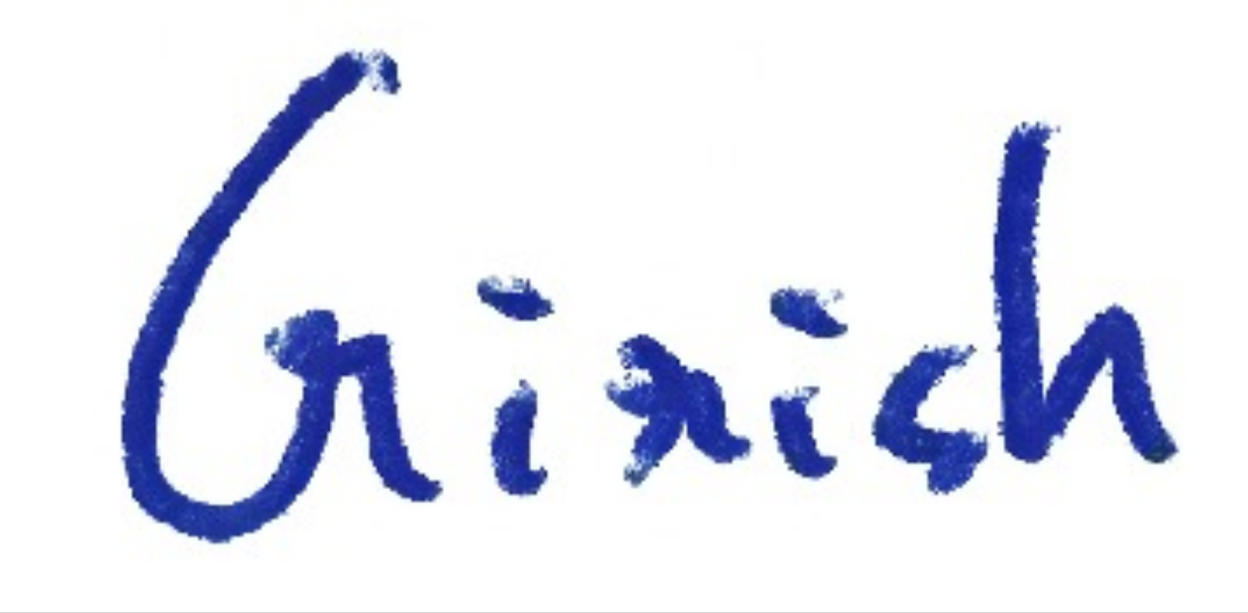  Inventor’s Signature Date 05-02-26 |  |  |  |  |  |   Inventor’s Signature Date 05-02-26
9. HOD review of application:

Signature of HOD_______________________________________________ Date__________________

Name ___________________________________________________________

AVVP Invention Disclosure Form Instructions
- The Patent and Technology Licensing Office (PTLO) reviews all Invention Disclosure forms as they are submitted. Where appropriate, the PTLO works to license AVVP inventions to industry for further development and commercialization. Any royalties received from licensing of the technology are shared with the inventor(s) according to AVVP Patent Policy.
The purpose of this form is to notify the PTLO of your potential invention and any relevant sponsorship and publication history. The form also serves to establish a legal record of the date of conception of the invention. This form should be submitted to the Patent and Technology Licensing Office when something new and useful has been conceived or developed, or when unusual, unexpected or non-obvious research results have been achieved and can be used.
- The following instructions apply to the corresponding numbered section on the form:
  - Provide a brief description of the Invention
  - Please attach information that describes the following:
    - General purpose
    - Technical description
    - Advantages and improvements over existing methods, devices or materials
    - Potential commercial application(s)
  - Include full legal names of all inventors (no initials). Inventors are those who have conceived or contributed an essential element of the invention, either independently or jointly with others, during the evolution of the technology concept or reduction to practice.
  - Please list all grants or external funds/sponsors contributing to the research. All disclosures must include the signatures of any principal investigator(s).
  - Invention ownership is closely tied with dates of conception and filing. In most countries, patents must be filed prior to any public disclosure. Some countries allow a one year grace period from date of publication or first oral disclosure. Please provide information as accurately as possible.
  - Reduction to practice, according to patent law, involves actual and complete use of the invention for its intended purpose. Such reduction to practice generally involves modeling of the invention and testing the model to determine whether it performs as intended, but this is not always necessary if the invention can be fully described.
  - Please indicate any industry or other representatives who may have contacted you or expressed an interest in the technology. This will assist the PTLO in licensing efforts.
  - Obtain signatures of all inventors and complete the information as indicated.
  - Please request your HOD to review and sign-off on the patent application.

